Browser functions//

because it is very late here, I will send visual design in uk morning. For now just create one menu on the right side of the browser (see image attached below)

Downloads - https://jxbrowser-support.teamdev.com/docs/guides/downloads.html

At the moment, it seems that files can be downloaded (it says default is to cancel download? would be good if it showed download progress box for big files, it just disappears when you click download. But I tested a 2mb file and it downloaded ok)

Cache - https://jxbrowser-support.teamdev.com/docs/guides/cache.html

need a Menu function to 'clear browser cache' eg temporary internet files. Needs to show the notification on completion,

Cookies - https://jxbrowser-support.teamdev.com/docs/guides/cookies.html

Browser needs to 1. Create cookies - Persistent cookies for user cache and session cookies for that session 2. Get cookies when browser is started with a profile (persistent cookies). Think this relates to session storate and local storage. The local storage needs to store the cookies for the user, and only if they click the 'Clear Session Cookies' menu item will they be removed from local storage.

Seems we can set path for persistent cookies. We may to discuss if this is copied from the cloud to local pc when the software launches, and copied back to cloud when software closes...

boolean success = cookieStore.put("http://www.google.com",

Cookie.newBuilder()

.creationTime(creationTime)

.expirationTime(expirationTime)

.name("name")

.value("value")

.domain(".google.com")

.path("/")

.build());

cookieStore.persist();

https://jxbrowser-support.teamdev.com/docs/guides/content.html#javascript

Need a menu function to clear cookies

Zoom - Please add zoom function so user can change page zoom

https://jxbrowser-support.teamdev.com/docs/guides/zoom.html

Printing - Please add menu function for Print > (which shows standard print dialog box with printer selection)

https://jxbrowser-support.teamdev.com/docs/guides/printing.html

Plugins - check this. All plugins should be enabled. I didnt have time to test reading a pdf file in the browser.

Dependencies for jxbrowser

I need this to work on Win 32/64 bi

and if possible Linux 64 bit and Linux 64 bit arm

and if possible macos 64 bit

One thing I cannot find is saving web pages to favourites list. Browseo has this. I cannot see a function for it in jx browser, please advise your thoughts on this

Please remove the text in address bar or make it so it disappears when user starts to type web url

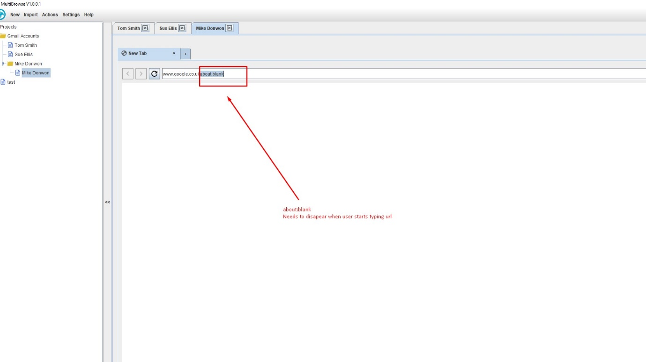

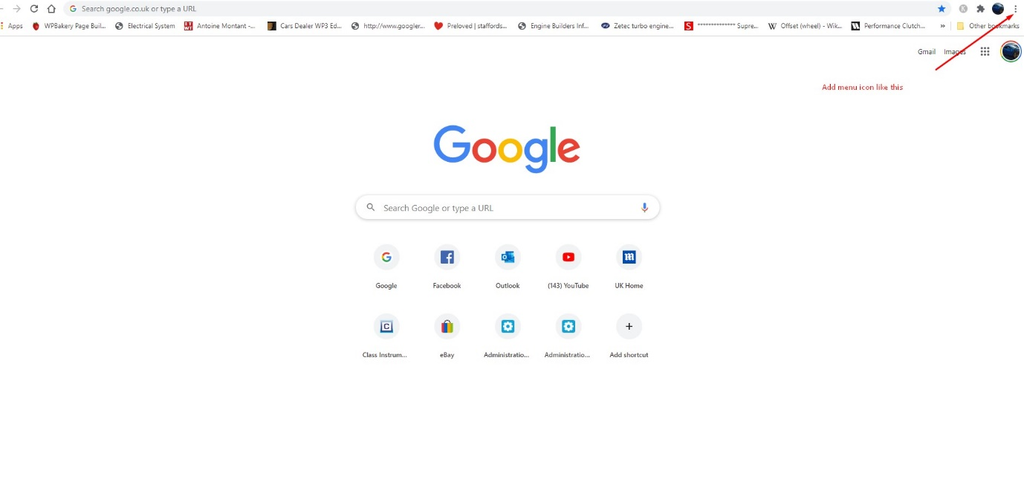

Menu icon in position on Right side of browser (not this far to the edge, but one icon position to the left maybe?)

If possible zoom function displays like this, or load default zoom adjustment box

